**Experiment No.09: Finance Manager App**

|  |  |  |  |
| --- | --- | --- | --- |
| **Roll No: 113** | **Name: Harshita Shetty** | **Div: B** | **Batch: B2** |

**Aim:** Implementation of income tax/ loan EMI calculator and deploy the same on real devices (Implementation of any real-time application).

**Theory:**

A Finance Manager is a professional responsible for managing the financial operations of a company or organization. Their primary role is to ensure the financial health and stability of the company by analyzing financial data, developing financial strategies, and making informed financial decisions.

Some key responsibilities of a Finance Manager include:

1. **Managing financial planning:** This involves developing and implementing financial plans and budgets for the company, as well as forecasting future financial performance.
2. **Financial analysis:** A Finance Manager must analyze financial data and reports to identify trends and patterns, and make informed decisions based on this information.
3. **Managing cash flow:** A Finance Manager is responsible for managing the company's cash flow, including monitoring accounts receivable and payable, and ensuring that the company has adequate cash reserves.
4. **Financial reporting:** A Finance Manager must produce accurate and timely financial reports, including income statements, balance sheets, and cash flow statements.
5. **Risk management:** A Finance Manager must identify and manage financial risks facing the company, including interest rate risks, currency risks, and credit risks.
6. **Compliance:** A Finance Manager must ensure that the company complies with all relevant financial regulations and laws.

To perform their role effectively, a Finance Manager must have strong analytical and problemsolving skills, as well as excellent communication and interpersonal skills. They should also have a deep understanding of financial concepts and accounting principles, and be proficient in the use of financial software and tools.

Overall, a Finance Manager plays a critical role in ensuring the financial success and stability of a company or organization.

**Program:**

**EMIActivity.java**

package com.cmt.taxcalculator;

import androidx.appcompat.app.AppCompatActivity;

import android.os.Bundle; import android.text.TextUtils; import android.view.View; import android.widget.Button;

import android.widget.EditText;

public class EMIActivity extends AppCompatActivity {

Button emiCalcBtn;

@Override

protected void onCreate(Bundle savedInstanceState) { super.onCreate(savedInstanceState);

setContentView(R.layout.activity_emi);

final EditText P = findViewById(R.id.principal); final EditText I = findViewById(R.id.interest); final EditText Y = findViewById(R.id.years); final EditText TI = findViewById(R.id.interest_total);

final EditText result = findViewById(R.id.emi) ;

emiCalcBtn = findViewById(R.id.btn_calculate2);

emiCalcBtn.setOnClickListener(new View.OnClickListener() {

@Override

public void onClick(View v) {

String st1 = P.getText().toString();

String st2 = I.getText().toString();

String st3 = Y.getText().toString();

if (TextUtils.isEmpty(st1)) { P.setError("Enter Principal Amount"); P.requestFocus(); return;

}

if (TextUtils.isEmpty(st2)) { I.setError("Enter Interest Rate"); I.requestFocus(); return;

}

if (TextUtils.isEmpty(st3)) { Y.setError("Enter Years"); Y.requestFocus();

return;

}

float p = Float.parseFloat(st1); float i = Float.parseFloat(st2);

float y = Float.parseFloat(st3);

float Principal = calPric(p);

float Rate = calInt(i);

float Months = calMonth(y);

float Dvdnt = calDvdnt( Rate, Months);

float FD = calFinalDvdnt (Principal, Rate, Dvdnt);

float D = calDivider(Dvdnt);

float emi = calEmi(FD, D);

float TA = calTa (emi, Months);

float ti = calTotalInt(TA, Principal);

result.setText(String.valueOf(emi));

TI.setText(String.valueOf(ti));

}

});

}

public float calPric(float p) {

return (p);

}

public float calInt(float i) {

return (i/12/100);

}

public float calMonth(float y) {

return (y * 12);

}

public float calDvdnt(float Rate, float Months) {

return (float) ((1+Rate)* Months);

}

public float calFinalDvdnt(float Principal, float Rate, float Dvdnt) {

return (Principal * Rate * Dvdnt);

}

public float calDivider(float Dvdnt) {

return (Dvdnt-1);

}

public float calEmi(float FD, Float D) {

return (FD/D);

}

public float calTa(float emi, Float Months) {

return (emi*Months);

}

public float calTotalInt(float TA, float Principal) {

return (TA - Principal);

}

}

**MainActivity.java**

package com.cmt.taxcalculator;

import android.content.Intent; import androidx.appcompat.app.AppCompatActivity;

import android.os.Bundle; import android.view.View; import android.widget.Button;

import android.widget.TextView;

public class MainActivity extends AppCompatActivity {

TextView t;

Button b1;

Button b2;

@Override

protected void onCreate(Bundle savedInstanceState) {

super.onCreate(savedInstanceState);// To Display The Layout from activy_main resource layout file.

setContentView(R.layout.activity_main); b1 = findViewById(R.id.button1); b2 = findViewById(R.id.button2);

b1.setOnClickListener(new View.OnClickListener() {

@Override

public void onClick(View view) {

Intent intent= new Intent(MainActivity.this, com.cmt.taxcalculator.IncomeActivity.class);

startActivity(intent); // On clicking on the button, Income Tax Calculator activity is called

}

});

b2.setOnClickListener(new View.OnClickListener() {

@Override

public void onClick(View view) {

Intent intent=new Intent(MainActivity.this, com.cmt.taxcalculator.EMIActivity.class); startActivity(intent);// On clicking on the button, EMI activity is called

}

});

}

public void exitApp() { finish();

}

}

**GSTActivity.java**

package com.cmt.taxcalculator;

import androidx.appcompat.app.AppCompatActivity; import android.os.Bundle;

public class GSTActivity extends AppCompatActivity {

@Override

protected void onCreate(Bundle savedInstanceState) { super.onCreate(savedInstanceState); setContentView(R.layout.activity_emi);

}

}

**IncomeActivity.java**

package com.cmt.taxcalculator;

import android.content.Intent; import androidx.appcompat.app.AppCompatActivity;

import android.os.Bundle; import android.view.View; import android.widget.Button; import android.widget.EditText; import android.widget.TextView;

import android.widget.Toast;

public class IncomeActivity extends AppCompatActivity {

EditText bs;

EditText hra;

EditText sa;

EditText lta;

TextView T1,T2,T3,T4,T5;

TextView tx;

TextView tx1;

Button b1;

Button con; @Override

protected void onCreate(Bundle savedInstanceState) { super.onCreate(savedInstanceState); setContentView(R.layout.activity_income); con=(Button)findViewById(R.id.next); bs=findViewById(R.id.edit1); hra=findViewById(R.id.edit2); sa=findViewById(R.id.edit3); lta=findViewById(R.id.edit4); T1=findViewById(R.id.t1);

T2=findViewById(R.id.t2);

T3=findViewById(R.id.t3);

T4=findViewById(R.id.t4);

T5=findViewById(R.id.t5);

tx1=findViewById(R.id.text3); b1=findViewById(R.id.go);

con.setOnClickListener(new View.OnClickListener() {

@Override

public void onClick(View view) { calculate();

}

});

b1.setOnClickListener(new View.OnClickListener() {

@Override

public void onClick(View view) {

try {

int HRA=Integer.parseInt(hra.getText().toString()); int LTAc=Integer.parseInt(lta.getText().toString());

double calcHRA=0.36*HRA; double calcLTA=0.12*LTAc;

T1.setText(""+bs.getText().toString());

T2.setText(""+calcHRA);

T3.setText(""+sa.getText().toString());

T4.setText(""+calcLTA); T5.setText(""+50000);

con.setEnabled(true);

}

catch (Exception e) {

Toast.makeText(getApplicationContext(), "An Error Occurred, Please try again!",

Toast.LENGTH_LONG).show();

}

}

});

} public void calculate()

{

Intent i=new Intent(IncomeActivity.this,NextIncome.class); i.putExtra("baseincome",bs.getText().toString());

i.putExtra("HRA",T2.getText().toString());

i.putExtra("SA",sa.getText().toString());

i.putExtra("LTA",lta.getText().toString());

startActivity(i);

}

}

**Output:**

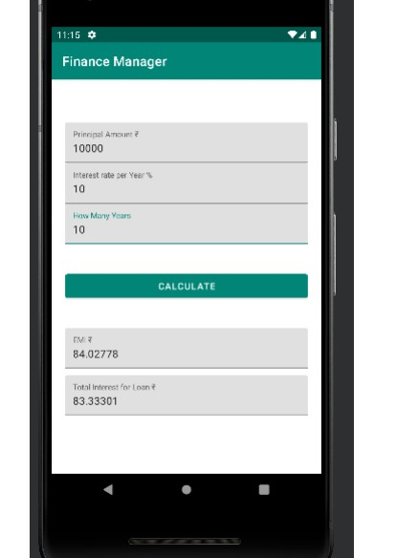

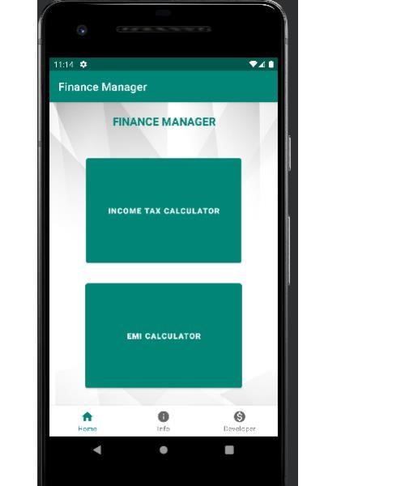

**GitHub Link: https://github.com/shettyharshita/Mobile_Computing**

**Conclusion:** The experiment was about the Income Tax/ Loan EMI calculator and deploying the same on real devices and the use to calculate EMI amount which is successfully implemented and verified.